# **Photocopier**

## ****Printig****

* Copy via the top feeder or on the glass plate
* Place to the left back corner near the arrow.
* Select **Copying (Kopiointi)**
* The default is 1 copy, but this can be changed
* Additional options, such as color, are available at the bottom of the screen (**2 sided (1-/2-puolisuus))**
* Finally, press **Start (Käynnistä)**

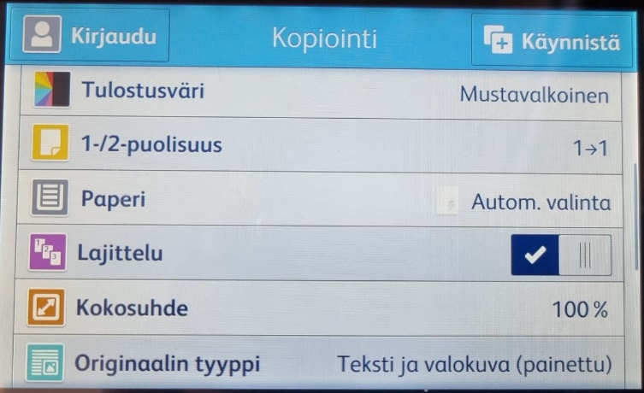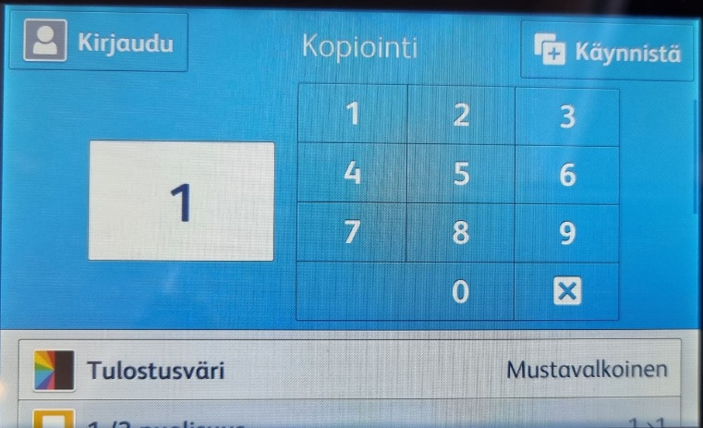

## Printing from mobile using PrintByXerox

The process involves sending an email to the photocopier via Xerox’s server.

* Send the document file to be printed as an email attachment to

[print@printbyxerox.com](mailto:print@printbyxerox.com)

* You will receive an email from Xerox:

Kaikki lähettämäsi asiakirjat hyväksyttiin. = All the documents you sent have been accepted.

Tulostusohje (Printing instructions):

Käytä tulostimessa @PrintByXerox MFP -sovellusta sähköpostiosoitteen tai tunnuksen avulla. = Use @PrintByXerox MFP app on the printer using your email address or ID

Xerox Workplace Cloud -sovelluksen lisensoidut käyttäjät voivat käyttää myös Xerox Workplace App -sovellusta tulostimen valitsemiseen, tulostusasetusten määrittämiseen ja hyväksyttyjen asiakirjojen tulostamiseen. =

Licensed users of the Xerox Workplace Cloud app can also use the Xerox Workplace App to select the printer, set print options, and print approved documents.

* After this, you can print your document from any Xerox machine that has the PrintByXerox feature.

**First time users**

* When you use the service for the first time, you will receive the following via email:
  + A notification about the registration of your email address
  + A password (you can also change it using the link provided) and an ID

Your email address xx@xx.x has been registered.

Your assigned password is:

You can set your password by clicking on the following link, or copy and paste it into your browser’s address bar.

<https://xwc.services.xerox.com/setpassword?id=a8b6027c-08b9-45a0-9a4f-f05606613b4b>

If you prefer, when logging into the @PrintByXerox MFP app, you may type in your ID (xxxx) instead of your email address.

* + **Remember these Xerox IDs for further use!**

### At the Xerox photocopier

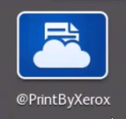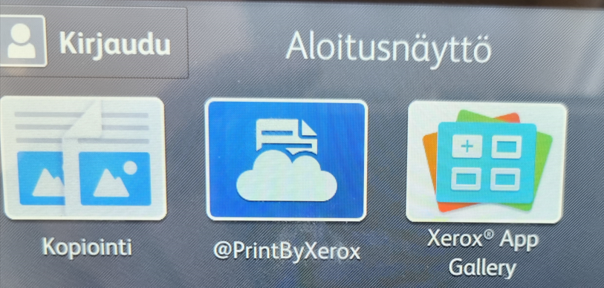

* Select PrintByXerox from control panel
* Enter your email address or ID (Email address from which you sent the file)
* Press OK
* Enter the password sent to you via email
* Press OK

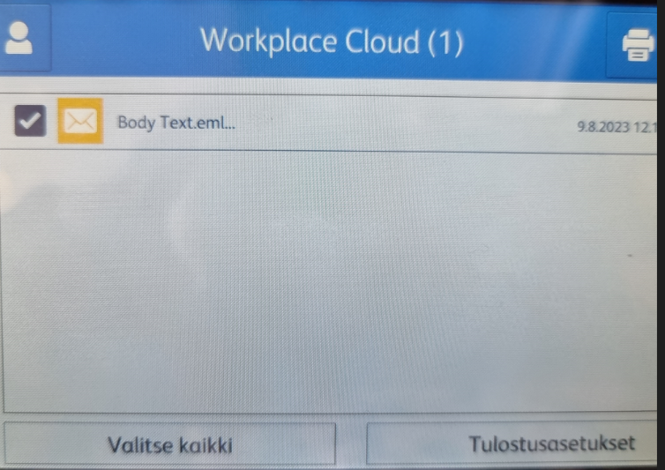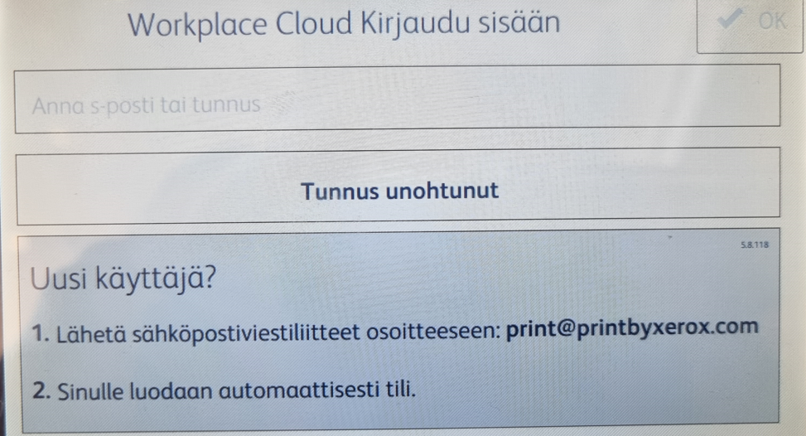

* All documents you’ve sent but not yet printed will be listed
* Select **Print Settings (Tulostusasetukset** where you can choose various options such as the number of copies, color, double-sided printing **(1-/2-puolisuus)**
* Press **Print**

